**Cutting-Edge Image Processing of Lower Gastrointestinal Track Using Deep Learning and Advanced Mathematics**

**Abstract:**

Lower gastrointestinal (GI) problems rely heavily on medical imaging for diagnosis and therapy. The Kvasir dataset is a useful tool for medical imaging research, especially in the field of gastroenterology. It is made up of high-quality movies and pictures taken during endoscopic operations that show the gastrointestinal tract, including the stomach, duodenum, colon, and esophagus. The data was collected through kaggle Accurate analysis may be hampered by these pictures' frequent susceptibility to noise and distortions. **In this article we report a new method using sophisticated mathematical analysis to improve and brighten pictures of the lower gastrointestinal (GI) tract, such as pylorus, normal-cecum, and ulcerative colitis images. Our goal was to enhance the picture quality through the use of various statistical filters, Gaussian functions, Fast Fourier Transform (FFT), and Inverse Fast Fourier Transform (IFFT). This would enable more precise classification and detection. According to our investigation, adaptive mean filtering plus Gaussian correction performed noticeably better than conventional bi-cubic filtering. In contrast to the bi-cubic filter, which yielded a PSNR of 42.06 and an MSE of 4.04, the combined filter technique provided a Peak Signal-to-Noise Ratio (PSNR) of 49.44 and a Mean Squared Error (MSE) of 0.73.** These findings suggest that the optimal image enhancement technique for lower GI tract exams is the combination of the adaptive mean filter and the Gaussian correction approach, which produces sharper, more detailed pictures. Additionally, the combined filter's improved image processing makes lower GI structures easier to see and understand, which helps doctors diagnose patients and plan treatments. Overall, our results highlight the value of using sophisticated filter approaches to improve image processing in lower gastrointestinal imaging, with the combined filter showing itself to be the best option for raising diagnostic precision and picture quality.

**Keywords:** Python, Image Analysis, Partial Differential Equation, Linear Algebra, Deep Learning, Computer Vision.

**Introduction:**

Diagnostic medicine has seen a radical transformation in recent years because of developments in medical imaging technology and the strength of deep learning algorithms. These developments have been very beneficial for some fields, such as lower gastrointestinal (GI) image processing. When it comes to the detection and treatment of a variety of gastrointestinal conditions, including gastrointestinal bleeding, inflammatory bowel disease, and colorectal cancer, lower GI imaging is essential [1]. However, clinician judgment has always played a major role in the interpretation of lower GI pictures, which can be laborious and subjective. Developing automated and improved image analysis tools for lower GI pictures by utilizing deep learning techniques and other computational methodologies in order to overcome these issues. These methods take advantage of deep learning models' capacity to extract significant characteristics and patterns from complicated pictures [2] , as well as the enormous volumes of data that are accessible from medical imaging archives.

We provide a thorough evaluation and analysis of the most recent methods for improved image processing of lower gastrointestinal pictures in this study. We explore the range of deep learning architectures, including convolutional neural networks (CNNs)[3], that are customized to the unique properties of photos from lower gravity. To further improve the precision and effectiveness of lower GI image analysis, we also investigate the integration of other cutting-edge computational methods, such as image segmentation, feature extraction, and image registration. We also draw attention to the intriguing directions that remain for further study and development, including the introduction of real-time feedback mechanisms for clinical decision support and the integration of multimodal imaging data.

All things considered, the combination of deep learning with other computer methods has the potential to completely transform the interpretation of lower gastrointestinal pictures, which would ultimately result in more precise diagnoses, individualized treatment plans, and better patient outcomes. Our goal in writing this work is to stimulate more research in this vital field of medicine by offering insights into the state of improved image analysis in lower GI imaging today.

**About the Data:**

The KVASIR dataset is a vital resource in the study of lower gastrointestinal (GI) problems, particularly for research utilizing computer-aided diagnosis. It consists of a range of endoscopic images and videos captured during colonoscopy procedures. The dataset includes a range of pathological states, such as polyps, ulcerative colitis, and colorectal cancer, to give a comprehensive representation of Lower GI illnesses. Especially in computer vision, KVASIR is utilized by researchers to develop and evaluate machine learning algorithms for automated colon and rectum abnormalities identification and categorization. The dataset is critical to advancing our knowledge of these conditions and facilitating the development of cutting-edge diagnostic methods and instruments that will improve the early detection and management of Lower GI problems.

The Kvasir dataset shows GI tract endoscopic procedures, clinical anomalies, and anatomical landmarks in hundreds of images per class. Endoscopy-trained medical specialists have verified and commented on the pictures[4]. There are enough images to support several applications, including visual retrieval, transfer learning, deep learning, and machine learning. Pathological findings include things like the Z-line, pylorus, cecum, and so on; anatomic landmarks include things like ulcerative colitis, polyps, esophagitis, and so on. We furthermore provide additional photo sets related to lesion removal, like "lifted and dyed polyp" and "dyed resection margins," among others. The collection is made up of images titled after the content that varies in resolution from 720x576 to 1920x1072 pixels.

**Computational Resources**

This study's computational studies were carried out with the help of Google Colab, a cloud-based platform that offers strong computational capabilities. To be more precise, we used the NVIDIA Tesla T4 GPU that was made accessible in the Colab environment to speed up our data-intensive workloads and deep learning models. Large datasets could be handled well because to the 16 GB of RAM and 100 GB of disk space offered by the Colab environment.

**Analysis of Kvasir Data**

1. **Image Smoothening**

**A. Average Filter**

One popular image processing method for reducing noise and producing a more aesthetically attractive outcome is picture smoothing. Smoothening can improve picture clarity for analysis or diagnosis when used on medical imaging datasets such as Kvasir, which includes gastrointestinal endoscopic images.

|  |  |  |
| --- | --- | --- |
| (m-1, n-1) | (m-1, n) | (m-1, n+1) |
| (m, n-1) | (m, n) | (m, n+1) |
| (m+1, n-1) | (m+1, n) | (m+1, n+1) |

$$Pixel\left(m,n\right)=data(m*width+n)$$

$$Pixel \left(i,j\right)= \sum_{x=-1}^{1}{\sum_{y=-1}^{1}{initialPixel(m+x,n+y)/9}}$$

$$Pixel \left(i,j\right)= \sum_{x=-1}^{1}{\sum_{y=-1}^{1}{initialPixel(m+x,n+y)/25 }}$$

Eight pixels encircle every pixel in the image, except the pixels at the margins, which are disregarded. then using the average of the nine pixels in the figure to recalculate each pixel's value.

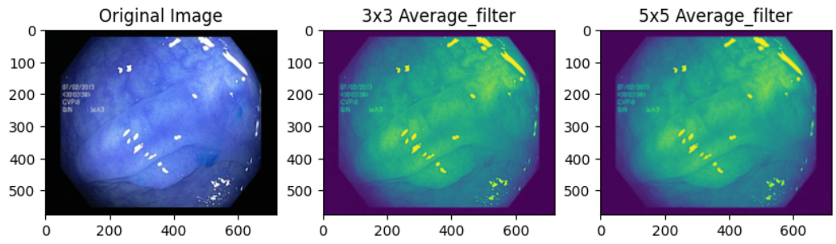

Figure 1 : Image Smoothening along with Different Filters

The average value[5] of the surrounding eight pixels and the pixel itself are substituted for each pixel's value shown inn Figure 1 on the centered picture, reducing the disparities between each pixel and improving the smoothness of the image. Nevertheless, the picture details are not well protected, and the image details are also lost during the denoising process, causing the image to become blurry. The difference in pixel density over the whole image is lower on the right side image since each pixel is now averaged over the 24 surrounding pixels. As a result, the 5x5 mask's processed picture is visibly smoother and more blurry than the 3x3 mask. In addition, mostly Unique pixels were attained.

**B.Median Filter**

In this section, the median filter substitutes the median value of the intensities within a specified neighborhood for each pixel's value. The median of the next eight pixels and the value of each pixel is used to replace its value; this reduces the disparities among all the pixels and smooths the image. After noise reduction, the objects' edges are sharper in the median filter than in the average filter shown in Figure 2. Furthermore, because it only processes the target pixel once, there is a greater variation between pixels.

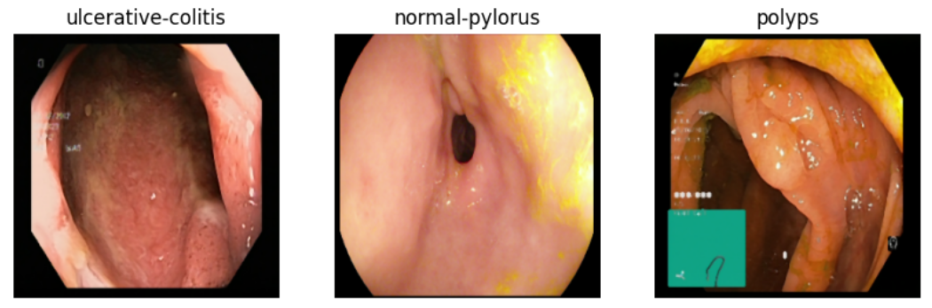

Figure 2: Median Filter Applied on the Kvasir Data

In medical photographs, the use of median and average filters might cause undesired distortion or blurring of important features, which could jeopardize the accuracy of the diagnosis. These filters might introduce artifacts or smooth down significant characteristics, which could lead to physicians making inaccurate evaluations. Rather, medical imaging usually uses more advanced techniques designed to guarantee diagnostic accuracy and preserve minute features. Improper use of filters on medical photos might have detrimental effects on patient care and diagnosis precision.

1. **A. Image Reduction**

In this filter, the scale to be reduced is and the original picture size is m*n, and the scale to reduce is $f\left(x\right) where (0<f\left(x\right)<1,$ and the output size will be $\left(m*f\left(x\right)\right)*(n*f\left(x\right))$ shown in Figure 3.

|  |  |  |  |
| --- | --- | --- | --- |
| X | 1/f(x) |  |  |
| X | X | X | X |
| 1/f(x) | X | X | X |
| X | X | X | X |

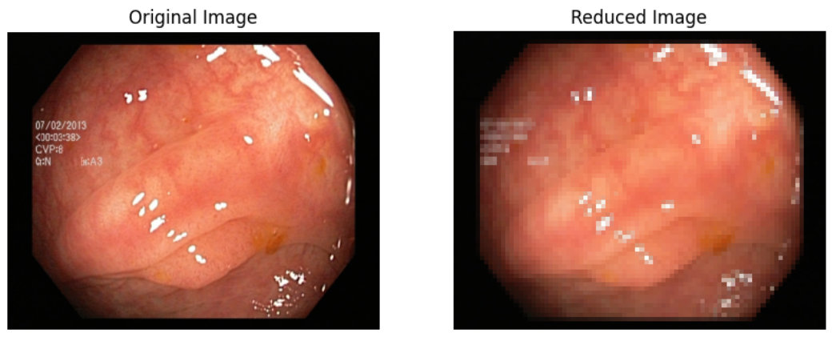

Figure 3: Image Reduction Applied on Pylorus Data

Because of their lower resolution, medical photographs that have undergone image reduction may lose important diagnostic information. The accuracy of medical diagnosis may be impacted by the reduction process[6], which may result in the loss of minute information and minor anomalies. In medical imaging, maintaining high picture resolution is essential for accurate analysis and interpretation.

1. **Image Sharpening**

A. Laplace Operator

In the laplacian operator picture sharpening is a widely used method in image processing. To calculate the local fluctuation of intensity in a picture, one can utilize the Laplacian operator, which is a second-order differential operator. Enhancing these differences makes the image look crisper shown in Figure 4.

$$Laplace=\frac{∂^{2}f}{∂x^{2}}+\frac{∂^{2}f}{∂y^{2}}$$

We get the difference from the Laplace Operator.

$$∇^{2}f\left(x,y\right)=4f\left(x,y\right)-f\left(x+1,y\right)-f\left(x-1,y\right)-f\left(x,y+1\right)-f(x,y-1)$$

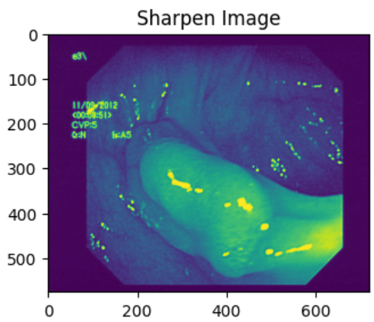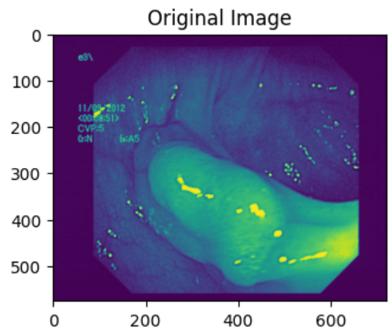

Figure 4 : Sharpening the Edges Using the Laplace Operator

The Laplacian filter draws attention to sharp contrasts in a picture, such as borders and edges. This may improve the visibility of anatomical features, lesions, polyps, or other anomalies in endoscopic images from the KVASIR dataset. The Laplacian filter may enhance noise in the pictures, such as speckle noise or artifacts from the endoscopic technique, which might result in a loss of image quality or the introduction of misleading features.

**B.Sobel Operator**

In this session, Edge detection is the main use for the Sobel operator. To find edges, it computes the image's gradient at each pixel in both the horizontal and vertical axes.

$$∇f=gradient\left(f\right)= \left[{g_{x} \atop g_{y}}\right]$$

$$∇f= \left[{{∂f}/{∂x} \atop {∂f}/{∂y}}\right]$$

Then, combining the Horizontal and the Vertical Gradient,

$$G= \sqrt[2]{G_{x}^{2}+G_{y}^{2}}$$

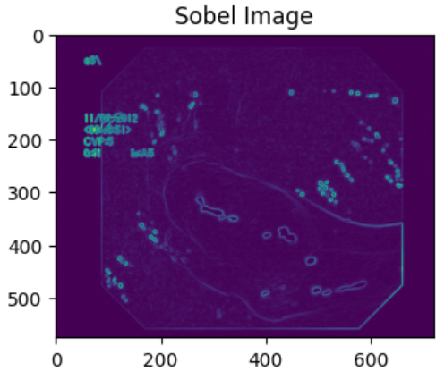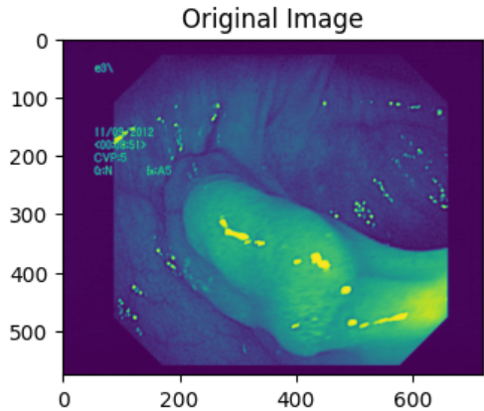

Figure 5: Edge Detection Using the Sobel Operator.

Following differentiation, the edge place's absolute value is quite big, whereas the flat place's value is nearly zero. However, the recovered picture contours are not always sufficient since the Sobel operator does not strictly separate the image's main body from its backdrop[7]. When it comes to noise, the Sobel operator is less sensitive than the Laplacian operator shown in Figure 5. It can deliver edge detection findings that are more dependable and fluid.

The particular needs of the application will determine whether Laplace or Sobel operators are best for image sharpening in medical photos. The Sobel operator computes gradients to highlight edges, but the Laplace operator effectively improves edges and fine details. However small features must be preserved in medical imaging, which is why Laplace operator is more appropriate since it can highlight minute structures without drawing attention to noise. Because of its gradient calculation, the Sobel operator may amplify noise, which might compromise the diagnostic precision of medical pictures.

4. **Gamma Correction**

In this part, Gamma correction, often referred to as gamma adjustment or gamma transformation, is a nonlinear process used to alter the brightness or luminance levels in digital photographs. To account for the nonlinear reaction, the pixel values of the pylorus must be changed. The properties of cathode-ray tube (CRT) monitors[8], which have a nonlinear connection between the input voltage and the brightness of the projected picture, are where the idea of gamma correction originated. The power-law function is frequently used to characterize the relationship:

Converting the pixel into the real number, and normalizing it $(f+0.5)/255$ where f is the original pixel value.

$$Gamma correction=f_{c}^{γ}, Where c \& γ are constant$$

Finally, denormalize the corrected value by taking the inverse value.

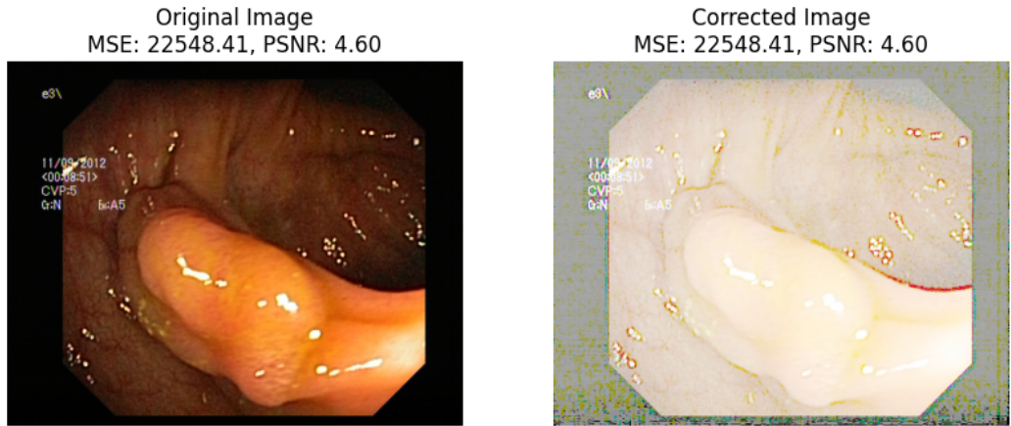

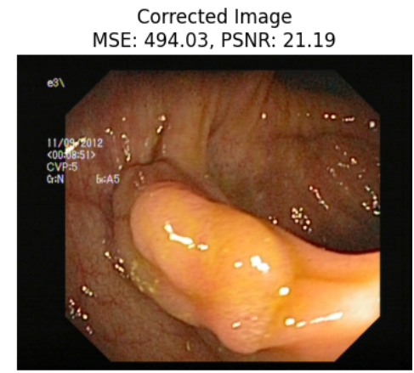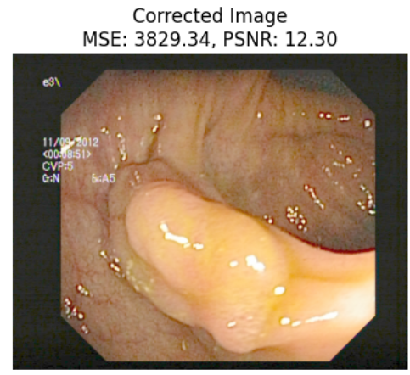

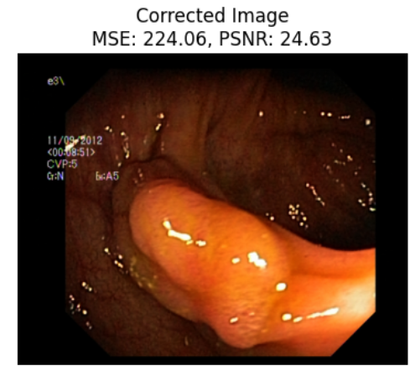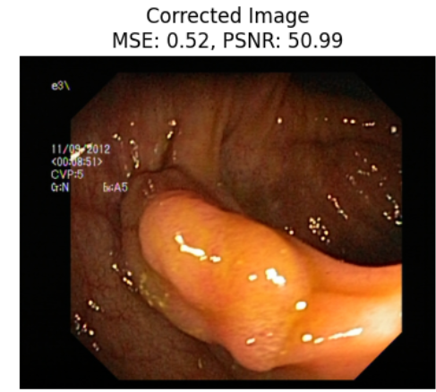

Figure 6: Gamma Correction along with Different Gamma Value

Metrics like PSNR (Peak Signal-to-Noise Ratio) and MSE (Mean Squared Error) are frequently used to assess how well processed or reconstructed pictures compare to their originals.

The mean squared error (MSE) calculates the difference between the processed (or reconstructed) picture and the original image. It is computed by averaging the respective pixel values of the two pictures over all pixels, then computing the square of the difference between those values.In terms of math, MSE is computed as follows:

$$MSE=\frac{1}{mn}\sum_{i=0}^{m-1}{\sum_{j=0}^{n-1}{{(Orijinal\left(i,j\right)-Processed\left(i,j\right))}^{2}}}$$

The ratio of a signal's maximal potential strength to the amount of corrupting noise that degrades the representational fidelity is called PSNR. PSNR is frequently used in image processing to assess the effectiveness of compression or reconstruction techniques.The formula for PSNR is as follows:

$$PSNR=10* \log_{10}\left(\frac{{MAX}^{2}}{MSE}\right)$$

With very little loss of picture quality, the processed pylorus image resembles the original with an MSE of 0.52 and a PSNR of 50.99. These results indicate that, in the context of KVASIR (pylorus) pictures shown in Figure 6, the employed algorithm for gamma correction or any other image enhancement approach has successfully enhanced the image quality, making it appropriate for additional analysis and diagnosis.

Gamma correction improves the visual quality of images by adjusting the brightness and contrast. In the Kvasir dataset, a gamma value of 0.98 produced the maximum PSNR, suggesting better visual quality. Gamma correction, when applied consistently to all pictures, can improve overall perceptual quality and help with a variety of image processing tasks without causing a noticeable loss in performance, even though it is computationally complex. Applying gamma correction with a value of 0.98 in the Kvasir dataset seems to be beneficial because it produced the highest PSNR. This implies that it may improve diagnostic precision in medical imaging jobs and successfully maintained image quality.

**5. Image Enlargement**

In this session, Enlarging a picture is the process of making it larger than it is. This is frequently done to enhance an image's visual quality. Boost details that the original image could have been too tiny on. Several frequently employed interpolation techniques for picture enlargement[9] include of:

1. The Nearest-Neighbor Method

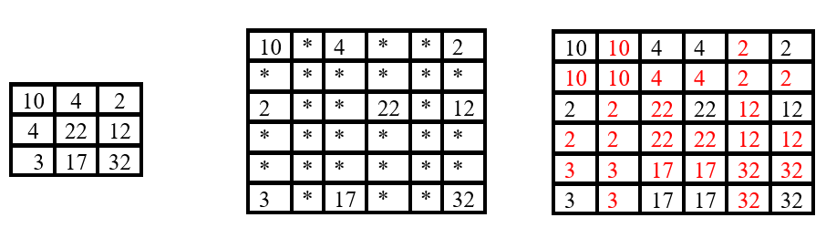

Figure 7: Structure of Nearest Neighbour of Images

In order to calculate the value of each new pixel in the expanded picture, this approach chooses the value of the closest pixel in the original image. While basic nearest-neighbour interpolation, particularly when increasing photos by a significant ratio, might produce blocky or jagged edges shown in Figure 7.

In medical pictures, enlarging the image may result in pixelation and interpolation artifacts that obscure diagnostic information. Images can become noisy and lose quality as they are enlarged, making it possible to miss important information needed for a diagnosis.

**6. Histogram Enlargement**

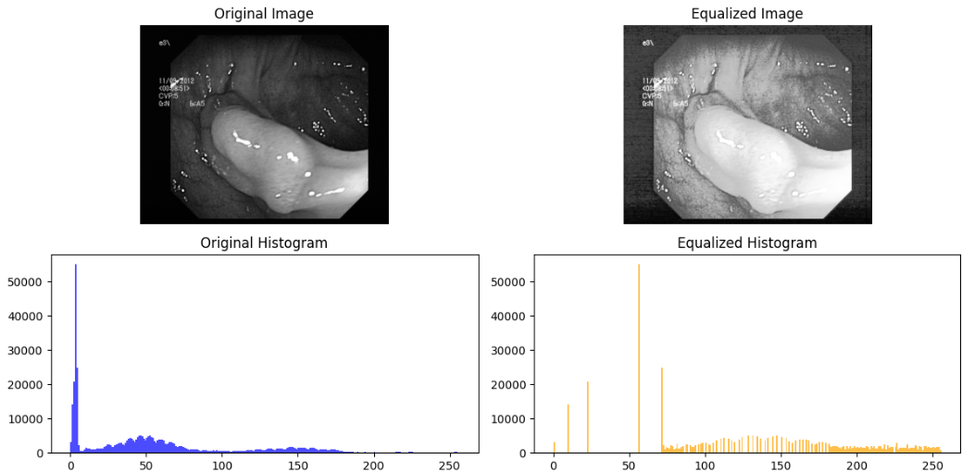

Figure 8: Histogram Enlargement Applied on the Kvasir Data.

In this part, the goal of image processing was to enhance a picture's interpretability and visual quality. Fundamentally, this technique works using an image's histogram, which shows the distribution of pixel intensities[10]. Histogram enhancement extends an image's intensity range to cover a greater range of values by dispersing these intensity values. Through the effective enhancement of contrast between various sections of the image, details that were previously hidden by excessive brightness, blackness, or low contrast are now more evident. A more balanced depiction of the image's content is produced by adjusting the cumulative distribution function (PDF) of the histogram using methods like histogram equalization. This produces a more consistent distribution of pixel intensities shown in Figure 8.

Following the use of image enlargement, the pixels of the picture tend to occupy the grey level and are uniformly distributed; this results in rich, dynamic visuals. After processing, there is a noticeable improvement in image contrast. (MSE = 5942.82, PSNR = 10.3908).

While histogram expansion can improve contrast, it can also make medical pictures more noisy and prone to artifacts, which might lead to inaccurate diagnostic interpretation. For medical imaging, other methods that minimize noise and selectively increase contrast could be more suitable in specific circumstances.

**6. Fourier Transform and Reconstruction**

In this area, discussed about reconstruction and the fourier transform are useful because they may reveal important information about the frequency composition and structure of signals and pictures. Fourier analysis breaks down signals and pictures into their frequency components[11], which makes it possible to extract pertinent characteristics, find patterns, and spot abnormalities.

$$F\left(u,v\right)=\frac{1}{\sqrt{MN}}\sum_{x=0}^{M-1}{\sum_{y=0}^{N-1}{f(x,y)e^{j2π(\frac{ux}{M}+\frac{vy}{N})}}}$$

$$f\left(x,y\right) is the original pixel,$$

$$F\left(u,v\right)is the outcomes of the Fourier Transform$$

After the four frequencies will meet at the center of the image were shown in Figure 9.,

$$f(x,y){(-1)}^{x+y}=F\left(u-\frac{M}{2},v-\frac{N}{2}\right)$$

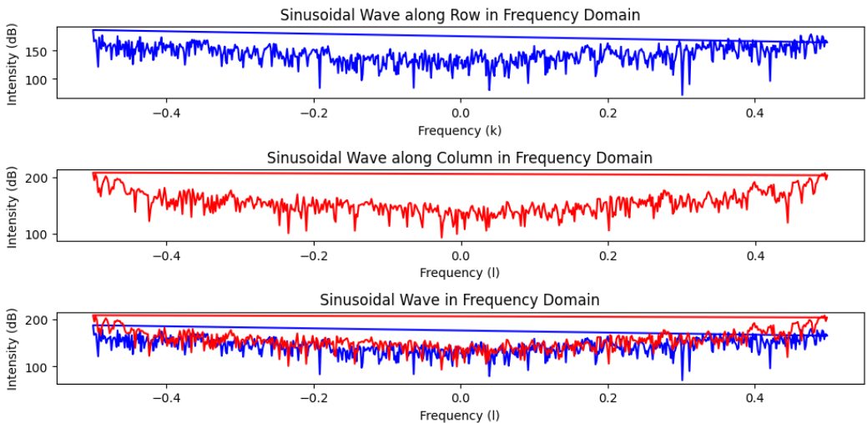

Figure 9: Transform and Reconstruction Using Fourier Transform.

DFT draws attention to the image's dominating frequencies, which are distinguished by large magnitudes in the frequency domain representation. The main patterns, textures, edges, and structures in the picture are matched to these dominating frequencies. DFT highlights periodic patterns or repeated structures in the picture, such textures or grids, by displaying comparable peaks in the frequency domain. The image's sharp edges and changes in intensity across distinct regions are highlighted in the frequency domain shown in Figure 10. In the DFT, these edges appear as high-frequency components.

$$f\left(x,y\right)=\frac{1}{\sqrt{MN}}\sum_{u=0}^{M-1}{\sum_{v=0}^{N-1}{F(u,v)e^{j2π(\frac{ux}{M}+\frac{vy}{N})}}}$$

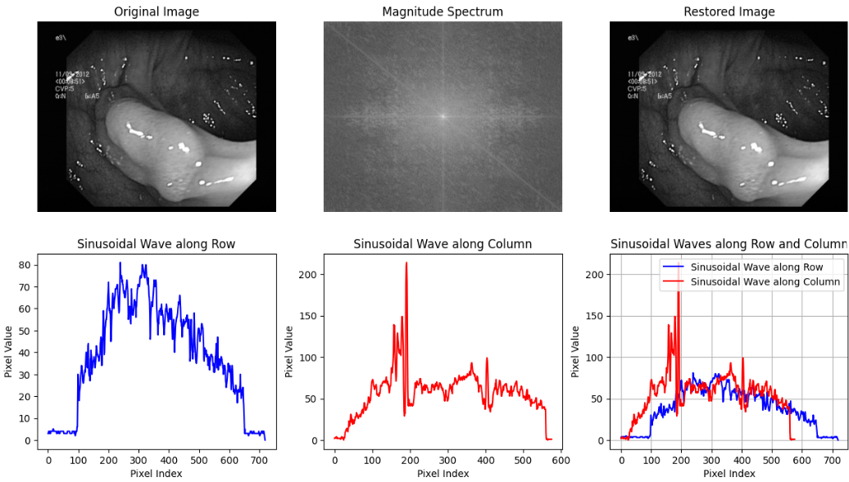

Figure 10: Sinusoidal Waves, Pixel Index, Magnetic spectrum and Restored Image Using DFT and IDFT Analysis.

In Figure 10, IDFT emphasizes the recovery of fine-grained data and picture features that could have been DFT-encoded in the frequency domain.

Although Fourier techniques can improve some aspects such as spatial resolution and frequency content, their usefulness differs depending on the imaging modality and task. But the computational complexity may be rather high, particularly when dealing with big datasets, therefore real-time processing calls for effective algorithms and powerful computers. Overall, the needs and limitations of the current medical imaging job should be carefully considered when comparing their efficacy and computing demands.

**7. Low Pass Filters and High Pass Filters**

In this session, Low-pass filters attenuate or eliminate high-frequency components of a signal or picture while permitting low-frequency components to flow through. High-pass filters attenuate or eliminate low-frequency components of a signal or picture while permitting high-frequency components to flow through. When pictures are smoothed or blurred with LPF, noise and detail are efficiently reduced yet low-frequency information like general brightness and large-scale structures are preserved[12]. In Figure 11, selectively highlighting high-frequency information and suppressing low-frequency content, HPF is utilized to improve edges and fine details.

$$H\left(u,v\right)=\frac{1}{1+{\left[D_{0}/D(u,v\right]}^{2n}}$$

$$H\left(u,v\right)=\left\{\begin{aligned}1, D(u,v)≤D_{0} \\ 0, D(u,v)>D_{0}\end{aligned}\right.$$

$D_{0}$ represents the radius, D(u,v) is distance between the two points.

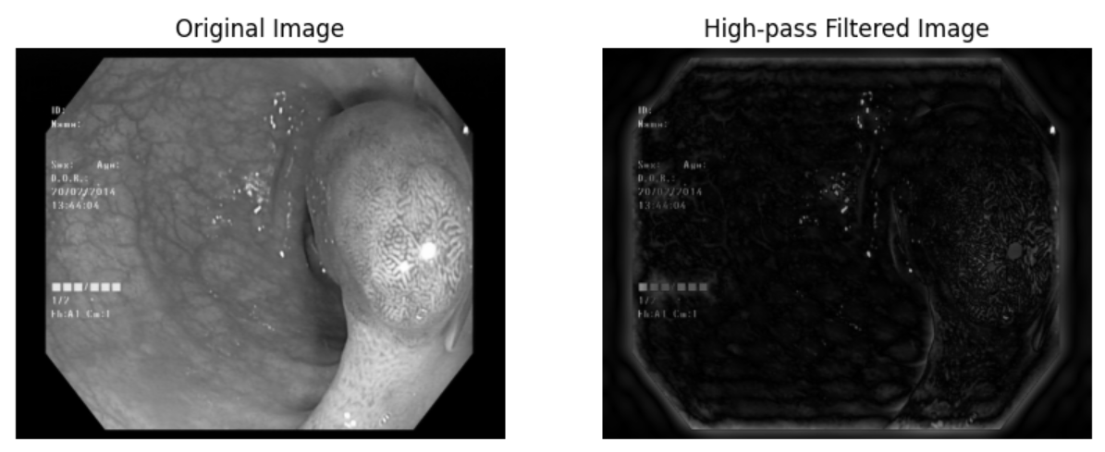

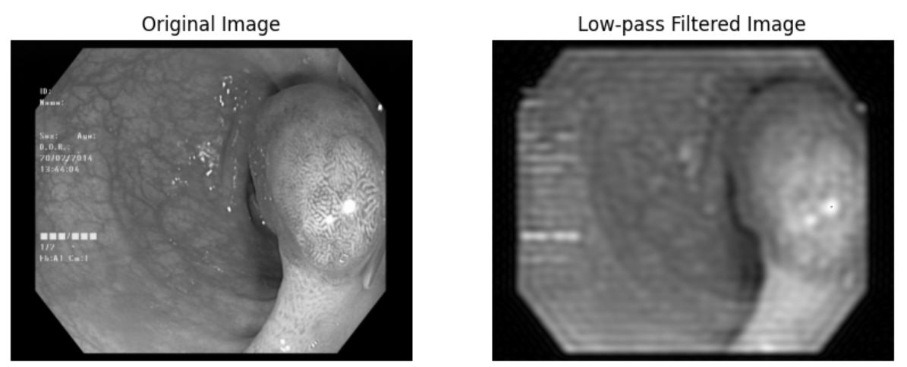

Figure 11: Different Low & High Pass Filters

Nevertheless, a number of variables, including the imaging modality, picture properties, and filter design and parameter selection, affect how effective these filters are. The best filter combinations must be determined by careful thought and testing.

**8. Homographic Filter**

In this area, discussing about, separating the components of light and reflectance[13] in a picture to improve the contrast and details. Normalizing illumination changes throughout a picture while maintaining the features seen in the reflectance component is the main objective of homomorphic filtering shown in Figure 12. The visibility of objects and structures in photos taken in different lighting situations is improved by this normalization shown in Figure 13.

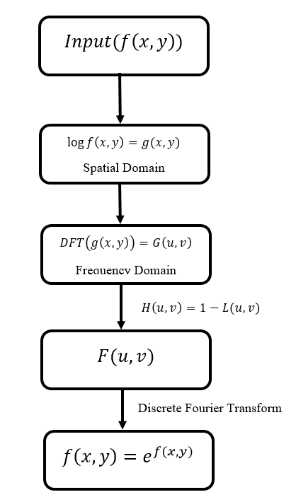

$$g\left(x,y\right)=log⁡(1+f(x,y)$$

$$g_{filtered}\left(x,y\right)=\exp\left(g_{filtered}\left(x,y\right)\right)-1$$

Figure 12: Structure of Homomorphic Filter

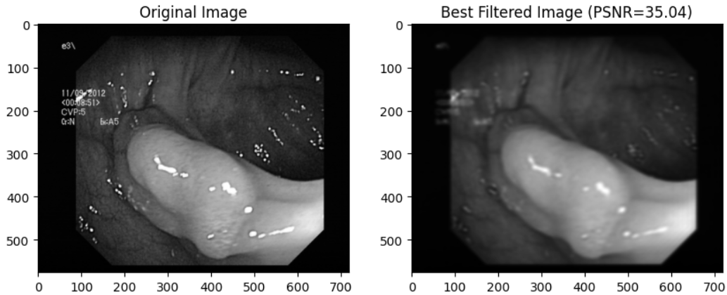

Figure 13: Homomorphic Filter Applied on the Kvasir Data.

In medical image processing, homomorphic filtering works well for improving contrast and adjusting for uneven lighting. Through the process of splitting an image into its illumination and reflectance components, homomorphic filtering can help reduce the effects of shadowing and enhance the visibility of fine features and structures in the picture. It helps with improved diagnosis and analysis by boosting characteristics in photographs taken in different lighting situations or with uneven illumination.

**Compare and Analyze the Noise Cancelling Algorithms:**

In this session[14], discussing and comparing about the various noise cancelling algorithms.

1. Arithmetic Mean Filter

The degree of smoothing is determined by the neighborhood's size, or kernel size. While smaller areas preserve more information and yet somewhat decrease noise, larger neighborhoods exhibit more noticeable smoothing effects. Because they might blur borders and features in the image, they might not be appropriate for all kinds of photos or situations when keeping little details is essential.

2. Geometric Mean Filter

It places less weight on extreme values in the neighborhood, the geometric mean filter tends to maintain edges and fine features better than the arithmetic mean filter. It may still, however, reduce noise and provide a beautiful image.

3. Alpha-trimmed Mean Filter

"Alpha-trimmed" is a procedure whereby a certain percentage of extreme values are eliminated from a dataset in order to prepare it for statistical calculations like mean or median. The proportion of extreme values to be removed from each neighbourhood before calculating the mean is denoted by "alpha". One kind of nonlinear image filtering method for lowering noise in photos while keeping edge details is the alpha-trimmed mean filter.

4. Adaptive Mean Filter

In contrast to conventional mean filters, which compute the mean using a fixed kernel size, an adaptive mean filter dynamically modifies the neighbourhood’s size according on local picture characteristics. As a result, it can reduce noise and better retain picture features. Comparative of various noise cancellation analysis were shown in Figure 14.

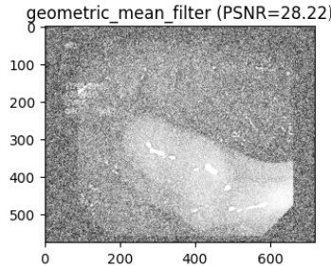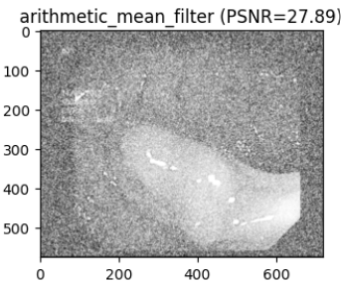

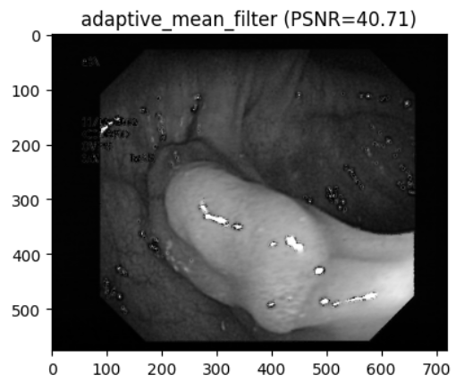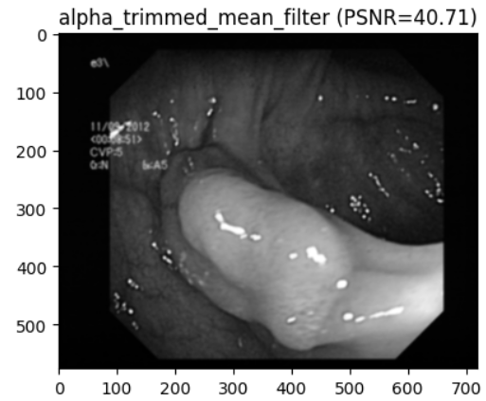

Figure 14: Analyse and Comparing of Noise Cancellation Filters along with PSNR Values.

Although it might blur edges, the arithmetic mean filter is straightforward and efficient for reducing noise. The Geometric Mean filter is better at preserving edges, but it might not be able to deal with sudden noise well. Alpha-trimmed filters combine edge preservation with resistance to outliers, but selecting the right parameters is crucial. The Adaptive Mean filter works well for fluctuating noise levels and keeping fine features since it modifies filter parameters locally.

**Compare and Analyse the Edge Detection Techniques:**

In this area[15], discussing and comparing about the various edge detection techniques.

In image processing, a straightforward edge detection approach is called the Roberts operator. It uses two 2x2 convolution masks to compute the image's gradient. To identify vertical and horizontal edges of the image, these masks are applied to it independently.

$$G_{x}=\left[\begin{matrix}1 & 0 \\ 0 & -1\end{matrix}\right],G_{y}=\left[\begin{matrix}0 & 1 \\ -1 & 0\end{matrix}\right]$$

$$G\left(x,y\right)=\sqrt{I_{x}{(x,y)}^{2}+I_{y}{(x,y)}^{2}}$$

Prewitt computes the image's gradient to identify edges, just like the Roberts operator does. But Prewitt uses bigger convolution masks (3x3) than Roberts (2x2), which could produce edge detection results that are smoother.

$$G_{x}=\left[\begin{matrix}-1 & 0 & 1 \\ -1 & 0 & 1 \\ -1 & 0 & 1\end{matrix}\right],G_{y}=\left[\begin{matrix}-1 & -1 & -1 \\ 0 & 0 & 0 \\ 1 & 1 & 1\end{matrix}\right]$$

Sobel provides superior edge localization and noise reduction compared to both the Roberts and Prewitt operators.

$$G_{x}=\left[\begin{matrix}1 & -2 & -1 \\ 0 & 0 & 0 \\ 1 & 2 & 1\end{matrix}\right],G_{y}=\left[\begin{matrix}-1 & 0 & 1 \\ -2 & 0 & 2 \\ -1 & 0 & 1\end{matrix}\right]$$

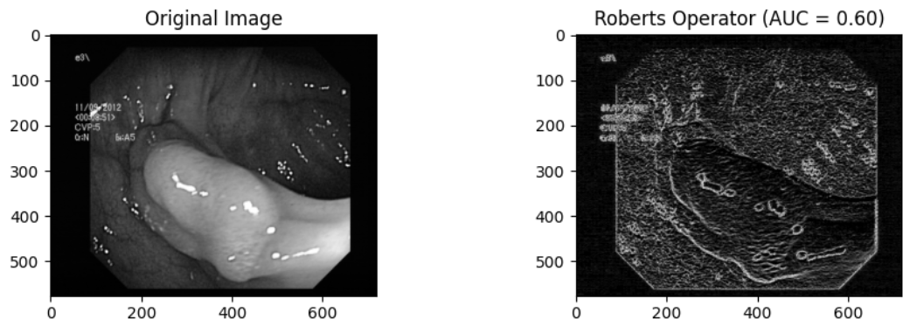

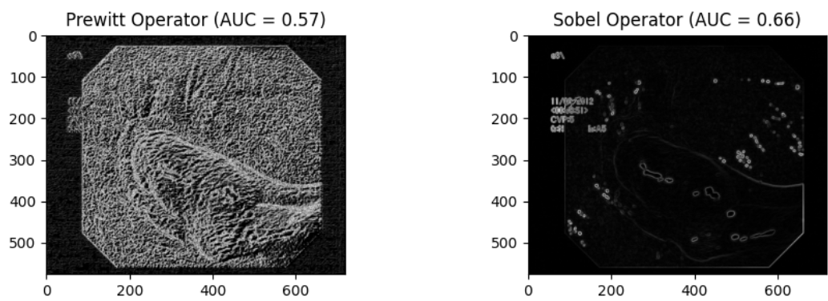

Figure 15: Analyse and comparing of Edge Detection Operators along with AUC Values

The AUC may be calculated mathematically in a number of ways, including the Mann-Whitney U statistic and the trapezoidal rule. When evaluating an edge detector's capacity to accurately detect edges while reducing false positives, the AUC is a useful statistic. Better performance in differentiating between edges and non-edges is shown by higher AUC values shown in Figure 15 and Figure 16.

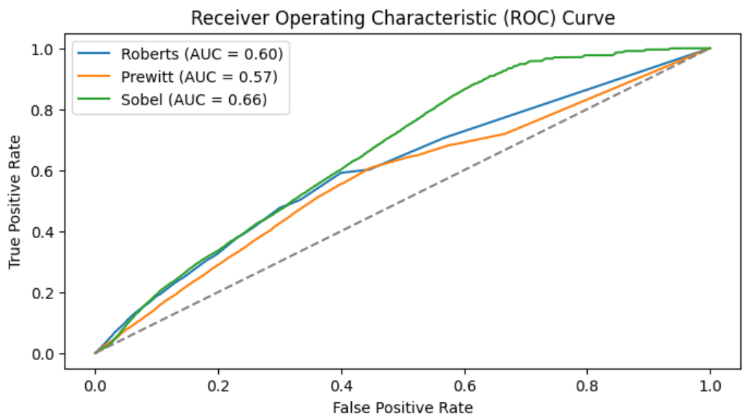

Figure 16: Analysis Using Area Under the Curve with Different Edge Detection Operators.

The Sobel filter is frequently regarded as useful for the Kvasir dataset, which consists of gastrointestinal endoscopy pictures, because of its capacity to detect edges with efficiency, particularly in images with intricate textures and structures like those present in endoscopic images. The gradient-based method used in the Sobel filter can successfully draw attention to significant characteristics seen in the gastrointestinal system, such as lesions, polyps, or anomalies.

**Analyzing the Kvasir Dataset with Interpolation Methods:**

In this session, discussing and analyzing about the various Interpolation methods[16] by applying them in image processing.

**1. Linear Interpolation:**

A straightforward interpolation method called linear interpolation is used to estimate values along a straight line between two known data points. The assumption is that there is a linear relationship between the data points.

$$y=y_{1}+\frac{(x-x_{1})}{(x_{2}-x_{1})}*(y_{2}-y_{1})$$

Particularly for big datasets or real-time applications with constrained computer resources, linear interpolation entails less complex computations, resulting in quicker execution times. The linearity between neighboring data points is maintained using linear interpolation. It is often less prone and more steady.

2. Bicubic Interpolation

The process of fitting a smooth surface to each pixel's neighborhood and using that surface to estimate the value of the pixel at the target position is known as cubic interpolation. This estimate is normally carried out using bi-cubic interpolation shown in Figure 17 using a 4x4 neighborhood of pixels.

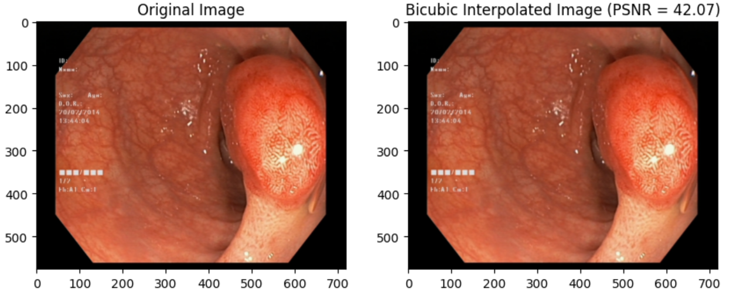

Figure 17: Bi-cubic Interpolation

**Discussions**

Coming to the discussion part, When applied image to a picture that results in a false classification, the arithmetic and median filters, out of all the filters and approaches I covered, eliminate information from the image while smoothing it out. When certain pixel lines are missing, the image becomes jagged and blurry with smoother edges, increasing the image size but not improving its clarity in image reduction and enlargement. By removing the fuzzy (dark and bright portions) and highlighting the photos, gamma correction—a non-linear color editing technique—alters the contrast of the photographs while still being effective. However, the computational complexity was quite high, and the datasets would vary in how the gamma value variance is changed.

In a histogram enlargement, the image's pixels are uniformly distributed and have a tendency to occupy the whole grayscale. As a result, following processing, the picture contrast is improved since the grey details tend to be rich and the dynamic range is wide. However, the event-based distribution of the pixels has changed the pixels in this instance. When evaluating DFT and IDFT, the algorithm's time complexity increases and its execution speed is quite sluggish when working with big datasets. After the picture is inverted and Fourier transformed, it is confirmed that the original image is recovered. Completely reject all frequency signals over the cut-off frequency on the low-pass and high-pass filters, and vice versa. so the picture becomes hazy.

Two different sorts of activities occur when anything enters the homomorphic filtering: the illumination component and the 2. reflectance part. It quickly modifies the portion and focuses on the high-frequency pictures, and vice versa, adjusting the images on their own. However, there are pixel-by-pixel alterations and features lost. When compared to other filters, the adaptive mean filter performs best, although alpha-trimmed filtering removes noise from photos contaminated by salt and pepper. However, you would want to change the k_size and alpha_size settings. Enhancing the alpha_size improves the image score (PSNR). The margins of the pictures in Roberts will become closer to either +45 or -45 degrees. On the edges, it has a great positioning precision. The Prewitt operator works well for detecting grayscale gradients and pictures with higher noise, however it is not appropriate for edges. Finding edges based on how close an edge is to its extreme value based on the weighted difference (Sobel) of its neighbor's intensity. Sobel is superior to all other edge detection and noise reduction filters because it combines the noise resistance and Gaussian smoothening outcomes.

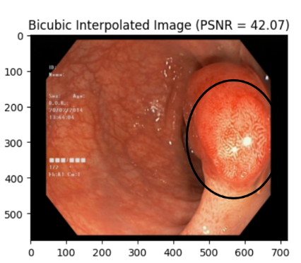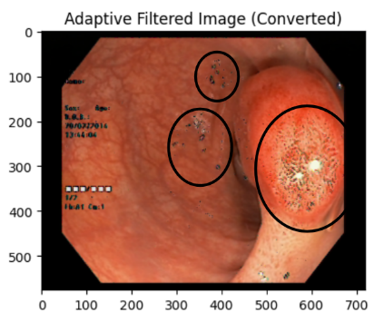

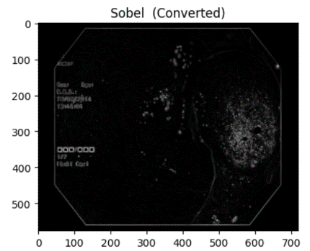

Figure 18: Comparative Analysis of Gamma correction + Adaptive filter and Bi-cubic Interpolation.

A comparison between a combined filter and bicubic interpolation is shown in Figure 18. Better outcomes were obtained with a 3x3 kernel for the adaptive filter, a kernel size of 15, and a Gamma value of 0.98. The combined filter's PSNR values were significantly higher—49.44—than those of the bicubic interpolation method, which was 42.06. Furthermore, the MSE values showed a notable improvement, with the combined filter receiving a score of 0.73 as opposed to 4.04 for Bicubic Interpolation. This implies that in terms of improving picture quality, the combined filter technique fared better than bicubic interpolation.

**Conclusion:**

By modifying the parameters, the Gamma Correction works well in the setting of the Kvasir dataset, which includes gastrointestinal endoscopic pictures for a variety of disorders such as polyps, ulcerative colitis, and esophagitis. The Adaptive Mean Filter may successfully minimize such noise while maintaining the clarity of edges and features in the picture. Sobel edge detection is important in recognizing edges and boundaries within endoscopic images. Sometimes it leads to complexity when dealing with complex datasets. Our investigation shows that sophisticated mathematical methods may effectively improve photographs of the lower gastrointestinal (GI) tract, such as those showing the pylorus, normal-cecum, and ulcerative colitis. We significantly improved the image quality by integrating Gaussian functions, Fast Fourier Transform (FFT), Inverse Fast Fourier Transform (IFFT), and numerous statistical filters. Notably, the classic bi-cubic filter was significantly outperformed by the combination of Gaussian correction and adaptive mean filtering. In contrast to the bi-cubic filter's 42.06 PSNR and 4.04 MSE, this combined technique produced a Peak Signal-to-Noise Ratio (PSNR) of 49.44 and a Mean Squared Error (MSE) of 0.73. These results demonstrate how the adaptive mean filter and Gaussian correction technique may work together to improve classification and detection accuracy by producing images with more clarity and detail.

Future developments will see SRRNet and SRGAN surpass standard filters in producing higher-resolution pictures with more precise details, better perceptual quality, less artifacts, and versatility to accommodate different image content and styles. They mark a major advancement in image-enhancing methods, especially for fields like satellite imagery, medical imaging, and photography where crisp images are crucial.

**Experimental Sources**

Lead Contact: Requests for more materials and information should be sent to Vasudevan, the primary contact, at svasudevanidvrs@gmail.com.

Material Availability: This Study did not generate any new materials.

**Online Content**

The following supplementary materials related to this study are available online:

**Lower Gastrointestinal Images:** High-resolution images of the lower gastrointestinal tract used in this study are available. These images can be accessed at the following Web: <https://datasets.simula.no/kvasir/>

**Code and Scripts:** The code and scripts used for the analysis and processing of the gastrointestinal images are provided. This includes all necessary scripts to reproduce the results presented in this paper. The code repository is available at: <https://github.com/Vasudev-2468/Image-Processing-of-Lower-Gastrointestinal-Track-Using-Deep-Learning-and-Advanced-Mathematics/blob/master/Analysis_FT_Along_with_Conclusions.ipynb>

**Data Files:** All relevant data files used in this study, including raw and processed data, are hosted on Kaggle. Researchers can download and use these files to replicate the study's findings. Access the data files at: <https://www.kaggle.com/datasets/meetnagadia/kvasir-dataset>

**References:**

[1]. P. Si, R. Xia, C. Lu, S. Li, J. Zhu and X. He, "Feature Context Aggregation Network with Edge Enhance for Endoscopic Gastrointestinal Bleeding Images Segmentation," 2021 IEEE 10th Data Driven Control and Learning Systems Conference (DDCLS), Suzhou, China, 2021.

[2]. T. K. Kho, K. S. Sim and F. F. Ting, "Gastrointestinal endoscopy colour-based image processing technique for bleeding, lesion and reflux," 2016 International Conference on Robotics, Automation and Sciences (ICORAS), Melaka, Malaysia, 2016.

[3]. Y. Oukdach, Z. Kerkaou, M. E. Ansari, L. Koutti and A. F. E. Ouafdi, "ConV-ViT: Feature Fusion-based Detection of Gastrointestinal Abnormalities using CNN and ViT in WCE Images," 2023 10th International Conference on Wireless Networks and Mobile Communications (WINCOM), Istanbul, Turkiye, 2023.

[4]. D. Gupta, G. Anand, P. Kirar and P. Meel, "Classification of Endoscopic Images and Identification of Gastrointestinal diseases," 2022 International Conference on Machine Learning, Big Data, Cloud and Parallel Computing (COM-IT-CON), Faridabad, India, 2022, pp. 231-235, doi: 10.1109/COM-IT-CON54601.2022.9850571.

[5]. Z. Miao and X. Jiang, "Further Properties and a Fast Realization of the Iterative Truncated Arithmetic Mean Filter," in IEEE Transactions on Circuits and Systems II: Express Briefs, vol. 59, no. 11, pp. 810-814, Nov. 2012.

[6]. Q. Lyu et al., "Cine Cardiac MRI Motion Artifact Reduction Using a Recurrent Neural Network," in IEEE Transactions on Medical Imaging, vol. 40, no. 8, pp. 2170-2181, Aug. 2021.

[7]. M. Z. F. Amara, R. Bandara and T. Silva, "SLIC Based Digital Image Enlargement," 2018 18th International Conference on Advances in ICT for Emerging Regions (ICTer), Colombo, Sri Lanka, 2018.

[8]. F. Kallel and A. Ben Hamida, "A New Adaptive Gamma Correction Based Algorithm Using DWT-SVD for Non-Contrast CT Image Enhancement," in IEEE Transactions on NanoBioscience, vol. 16, no. 8, pp. 666-675, Dec. 2017.

[9]. M. Z. F. Amara, R. Bandara and T. Silva, "SLIC Based Digital Image Enlargement," 2018 18th International Conference on Advances in ICT for Emerging Regions (ICTer), Colombo, Sri Lanka, 2018.

[10]. N. Mao, H. He, F. Chen, Y. Yuan and L. Qu, "Reversible Data Hiding of JPEG Image Based on Adaptive Frequency Band Length," in IEEE Transactions on Circuits and Systems for Video Technology, vol. 33, no. 12, pp. 7212-7223, Dec. 2023.

[11]. S. S. Chandra, N. Normand, A. Kingston, J. Guédon and I. Svalbe, "Robust Digital Image Reconstruction via the Discrete Fourier Slice Theorem," in IEEE Signal Processing Letters, vol. 21, no. 6, pp. 682-686, June 2014.

[12]. P. D. Laforge, R. R. Mansour and M. Yu, "The Use of Low-Pass Filters as Impedance Inverters for Highly Miniaturized Superconducting Bandstop Filter Designs," in IEEE Transactions on Applied Superconductivity, vol. 21, no. 3, pp. 575-578, June 2011.

[13]. Á. Chavarín, E. Cuevas, O. Avalos, J. Gálvez and M. Pérez-Cisneros, "Contrast Enhancement in Images by Homomorphic Filtering and Cluster-Chaotic Optimization," in IEEE Access, vol. 11, pp. 73803-73822, 2023.

[14]. H. -Y. Tsai et al., "3-D Wireless Power Transfer With Noise Cancellation Technique for −62-dB Noise Suppression and 90.1% Efficiency," in IEEE Solid-State Circuits Letters, vol. 6, pp. 213-216, 2023.

[15]. A. H. Abdel-Gawad, L. A. Said and A. G. Radwan, "Optimized Edge Detection Technique for Brain Tumor Detection in MR Images," in IEEE Access, vol. 8, pp. 136243-136259, 2020.

[16]. G. J. Grevera, J. K. Udupa and Y. Miki, "A task-specific evaluation of three-dimensional image interpolation techniques," in IEEE Transactions on Medical Imaging, vol. 18, no. 2, pp. 137-143, Feb. 1999.